ORIENTAL CAT ASSOCIATION

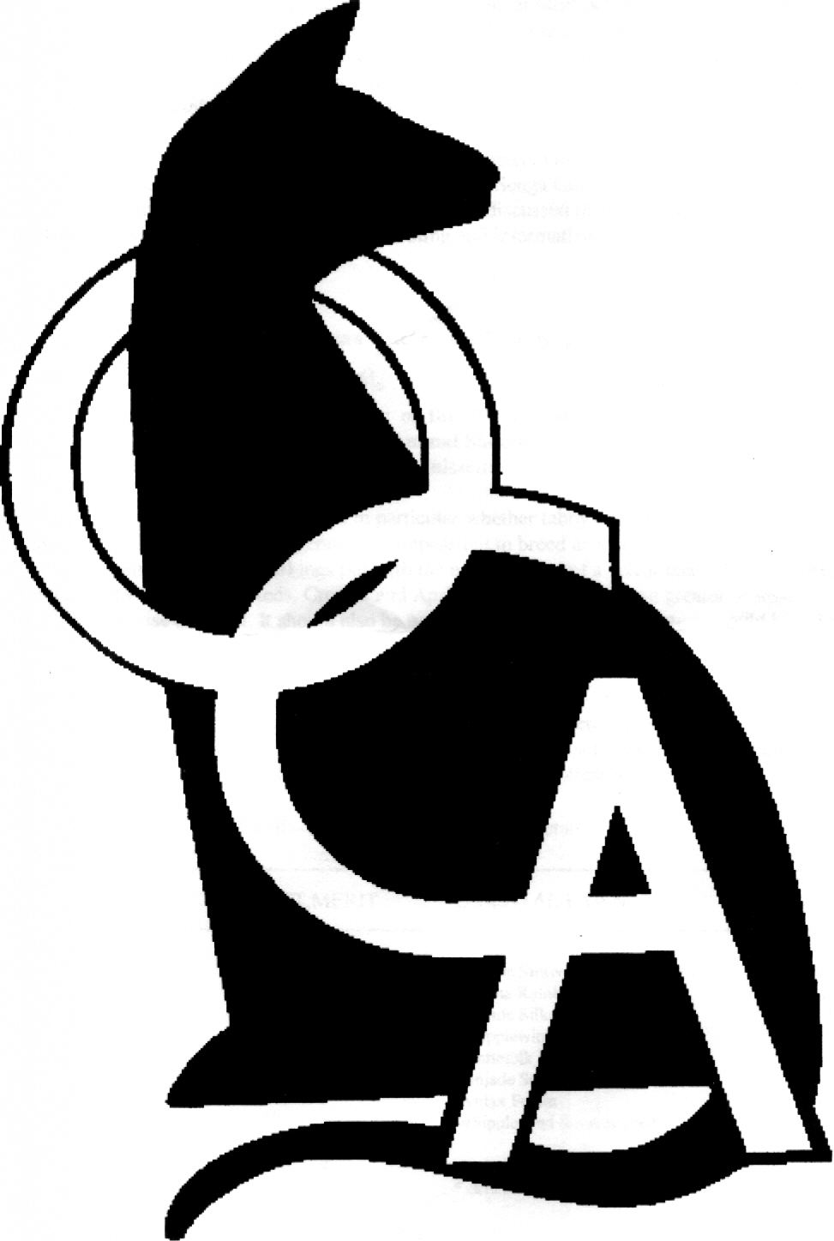

The Silver Varieties

Introduction

During the late 1960's Pat Turner had come to the belief that the gene producing silver in cats was not, as then currently accepted, a recessive gene at the same locus as Siamese but a dominant gene at a different locus. There was very little interest at that time in possible new colours and Pat found it difficult to collect any data to support or disprove her theory.

However, in 1970 a person owning some pedigree cats and kittens threatened that unless they were taken off her hands they would be euthanased. Pat was told that two of the queens were Chinchilla and that the two kittens were silvery coloured hybrids from a mating with one of the Siamese. All the cats were removed to a temporary home whilst new homes were found for the Siamese, and then Pat spent some time considering the fact that the hybrid kittens from the Siamese/Chinchilla mating were reported to be silver in colour.

Here, possibly, was the opportunity to obtain the data on the way the silver gene was inherited. She discussed the matter with Roy Robinson and they agreed that the two Chinchilla queens should be test mated and the original hybrid kittens be bred from when they were mature enough.

Before any firm decisions could be made Pat and Roy had to be certain that the kittens were silver. It was arranged that they should be taken to Mary Dunhill for her opinion. Mary confirmed that the kittens were indeed silver and the die was cast!

The two Chinchilla queens were Marisarni Retara and Marisarni Cindy, and Pat registered the kittens as Scinta Celeste and Scintasilva Sue. Cindy was mated to a black shorthair and Retara to a Lilac Point Siamese. Of the kittens, Celeste never bred but Sue was successfully mated to a Red Point Siamese carrying blue and her kittens were born in 1971 - a Foreign Black, an Oriental Smoke, two Oriental Shaded Silvers and a Siamese.

This was the first ‘second-generation’ litter of the new silver breeding programme to be born.

Breeding the Silver varieties

Breeding Silver cats could be believed to be comparatively easy because the Silver (or 'Inhibitor') gene has been proved to be dominant, as Pat Turner suspected. Therefore, to produce Silver kittens at least one parent must be Silver itself. The name 'Inhibitor' is a very good description for the way this gene works because it actually inhibits (or stops) the normal colouring of the coat and replaces it with silver. In the same way as body type, or intensity of soundness of colour depends on the action of many polygenes, the inhibiting action of the silver gene varies. Therefore, just as we see Havanas with unsound coats, or Oriental Tabbies with unclear coat markings, so we can see Silver cats
with varying degrees of silver showing in their coats. This is thought to be attributable to the wideband gene.

Varieties recognised

At the moment, there are four separate varieties recognised by the OCA, they are as follows:

- Oriental Smoke: - Championship Status from June 2001

The genotype of the Oriental Smoke is identical to that of the Self varieties (i.e. Havanas, Oriental Blacks, etc) and therefore can be bred in any colour, although the majority of those exhibited have been Black or Chocolate. The difference of course is the presence of the Inhibitor gene which produces the silver undercoat. Smokes are non-agouti silver cats, and any tabby markings seen are ghost markings similar to those seen in the coat of a non-silver self coated cat. Often these cats have silvery frown markings on the forehead and silvery rings around the eyes which helps the identification of kittens. Because of difficulties in the classification of young kittens from Smoke x Self, pedigree breeders are often warned against too early registration and are advised to check the coat very carefully before making a final decision. The Oriental Smoke coat is usually at its best when the cat is adult and kittens are often very much darker and show much less undercoat. Newcomers to the variety may easily mistake a slow developing Smoke coat for a solid coat, especially as some newborn non-silver kittens can show silvery frown lines at birth, and this leads breeders to believe that kittens lacking the frown lines are not Smokes.

- Silver Tabbies: - Championship Status from June 1996

The Silver Tabby is of the same genotype as the Standard coloured tabby, but with the introduction of the Inhibitor gene which prevents the production of yellow pigment in the hair. Thus, the areas of the hair, which, in the Standard Tabby, would be, fawn or yellow becomes silver. The Silver Tabby shows the minimal effect of silver with the colour of the overlying tabby pattern showing bright contrast and silver restricted to the base colour only. The actual silver colour is affected slightly by the basic colour of the cat so that in the Chocolate Silver the silver areas are pale pinkish silver, and so on. Also the Inhibitor gene affects the depth of colour in the tabby markings, turning the base silver. The silver effect is probably best seen on the Black Silver Tabby, but even in this group the degree of pigmentation varies so that some Black Silver Tabbies show silver areas that are almost white and others have silver areas that are distinctly grey. The desired effect is as described by breeders who remember the old sixpenny coins, the colour of a silver sixpence - neither too white nor too grey.

- Shaded Silvers: Championship Status from June 1997

The Shaded Silver is also an agouti cat, and therefore of the same genotype as the Silver Tabby. However, careful selection of breeding stock is producing a cat with no visible tabby markings on the body and only vestigial barring on the face, legs and tail. The basic colour is clearly visible on the surface of the coat and on some of the hair shaft, but it is not sound to the roots, with a deep silver undercoat. There is far more silvering of the undercoat than seen in the Smokes - almost as if the Inhibitor gene is 'pushing' the colour up the hair shaft. Shaded Silvers are very striking, and often difficult to identity from a Silver Tabby when young. Sometimes the full beauty of their coat will not be seen until the cat is almost two years old. Shaded Silvers can show a degree of tabby markings in their coat until maturity.

Further details of the varieties discussed in this leaflet and of the Oriental Cat Association can be obtained from the OCA Secretary.

© 2002 Oriental Cat Association

